Lab 08: File Handling & Regular Expressions

Lab Learning Objectives
- Read data from text files using Python.
- Create and write new files programmatically.
- Read CSV files using both built-in Python and pandas.
- Apply regular expressions to validate or search text patterns.
- Use file handling and regex together in a simple real-world problem.

File Handling:
Python has several functions for creating, reading, updating, and deleting files.
The key function for working with files in Python is the open () function. The open () function takes two parameters: filename, and mode.

Example 1: Read a text file
File name: 01_read_text_file.py
This program opens an existing text file and prints its content on the terminal.
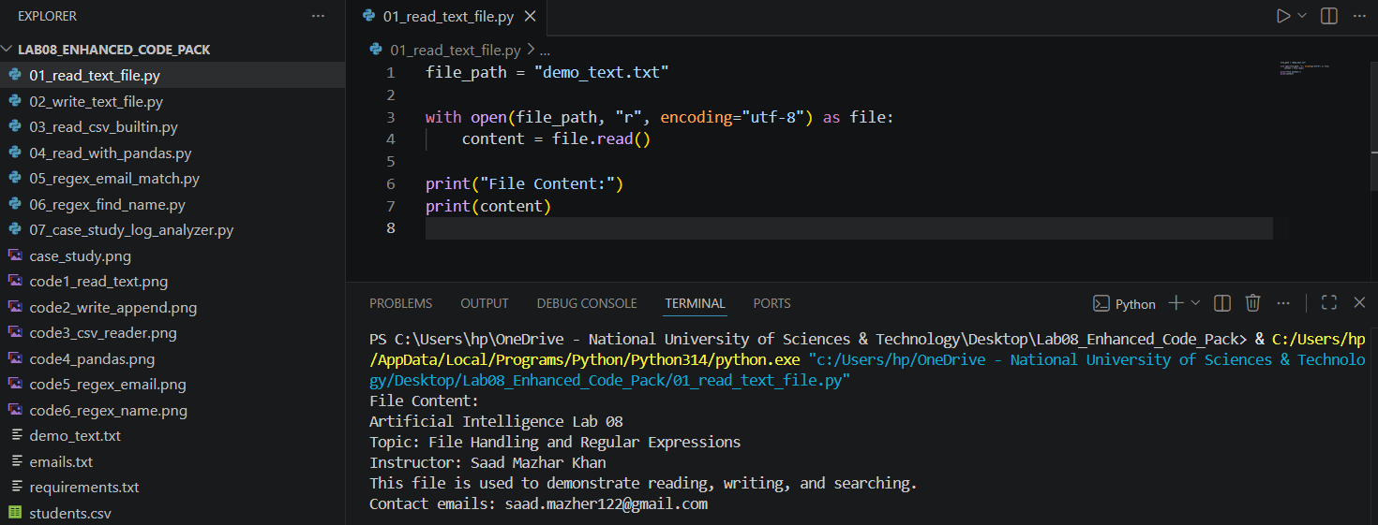

There are four different methods (modes) for opening a file:
Mode | Description
r | Read (default, error if file not found)
a | Append (creates file if not exists)
w | Write (overwrites file)
x | Create (error if file exists)

Example 2: Create and write a text file
File name: 02_write_text_file.py
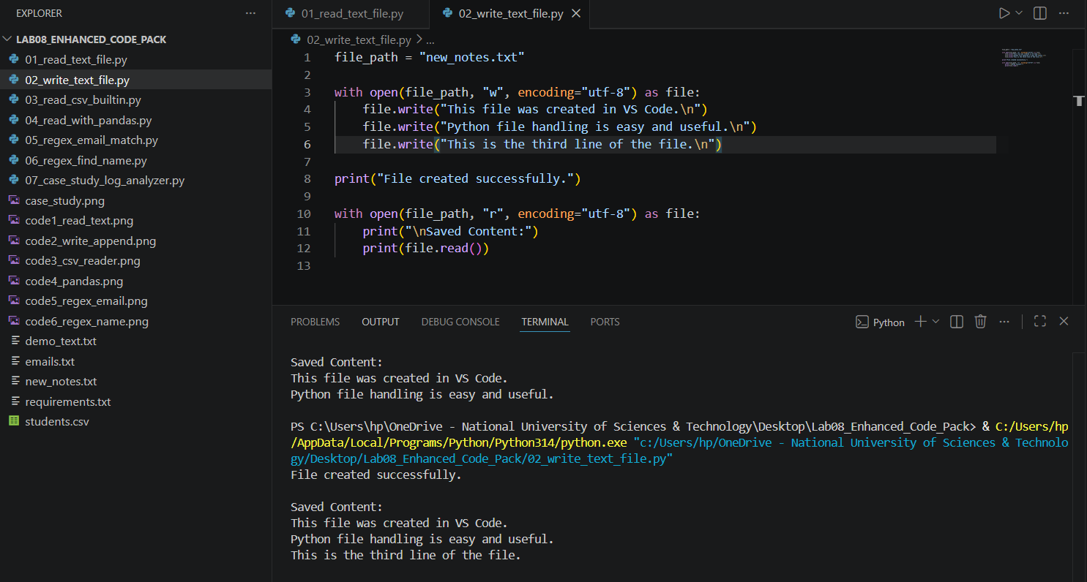

Code Example 3: Read a CSV file using built-in csv module
File name: 03_read_csv_builtin.py
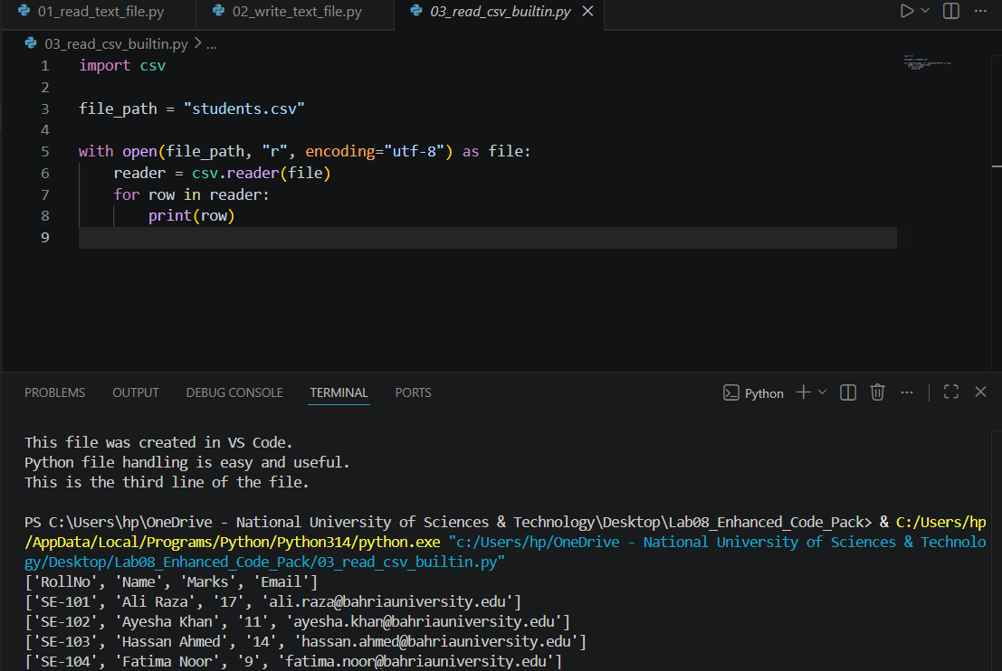

Code Example 4: Read text and CSV using pandas
File name: 04_read_with_pandas.py
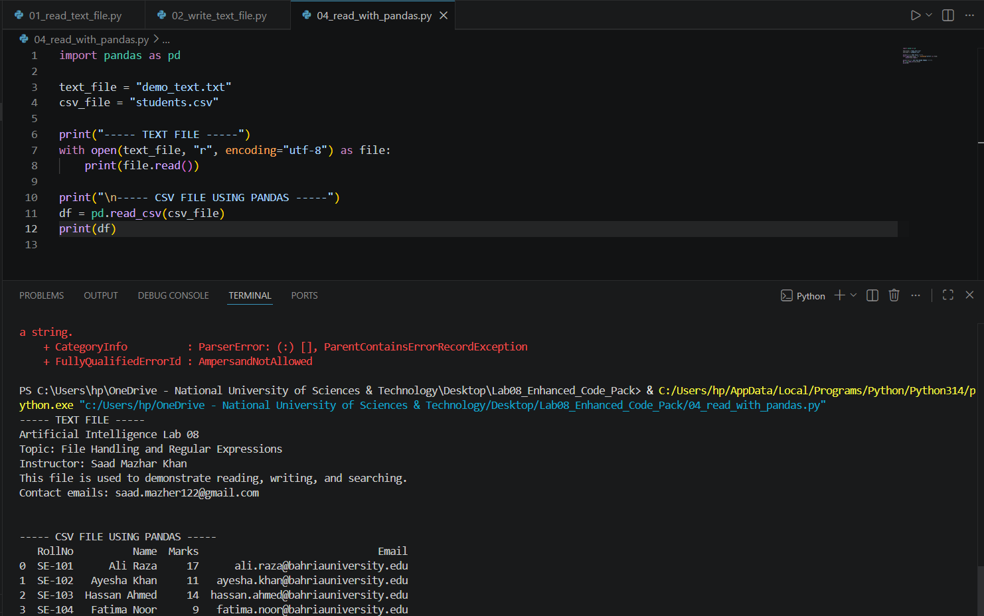

RegEx:
A RegEx, or Regular Expression, is a sequence of characters that forms a search pattern. RegEx can be used to check if a string contains the specified search pattern.
Python has a built-in package called re, which can be used to work with Regular Expressions. Import the re module.
When you have imported the re module, you can start using regular expressions:

The re module offers a set of functions that allows us to search a string for a match:

Function | Description
findall() | Returns a list containing all matches
search() | Returns a Match object if there is a match anywhere in the string
split() | Returns a list where the string has been split at each match
sub() | Replaces one or many matches with a string

String metacharacters are characters that have special meanings in regular expressions.
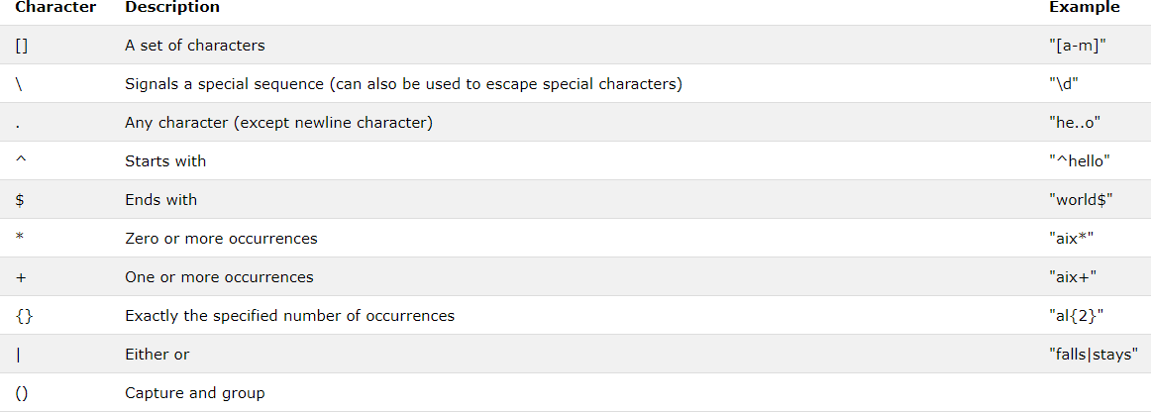

A special sequence is a \ followed by one of the characters in the list below, and has a special meaning:
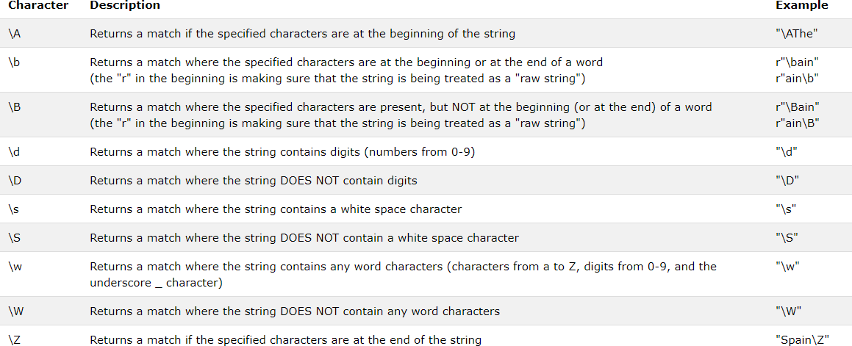

Example 5: Build a regex to match emails
File name: 05_regex_email_match.py

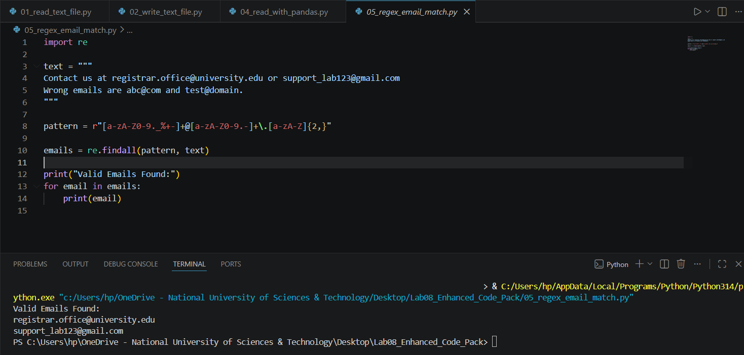

Example 6: Find your name in a string
File name: 06_regex_find_name.py

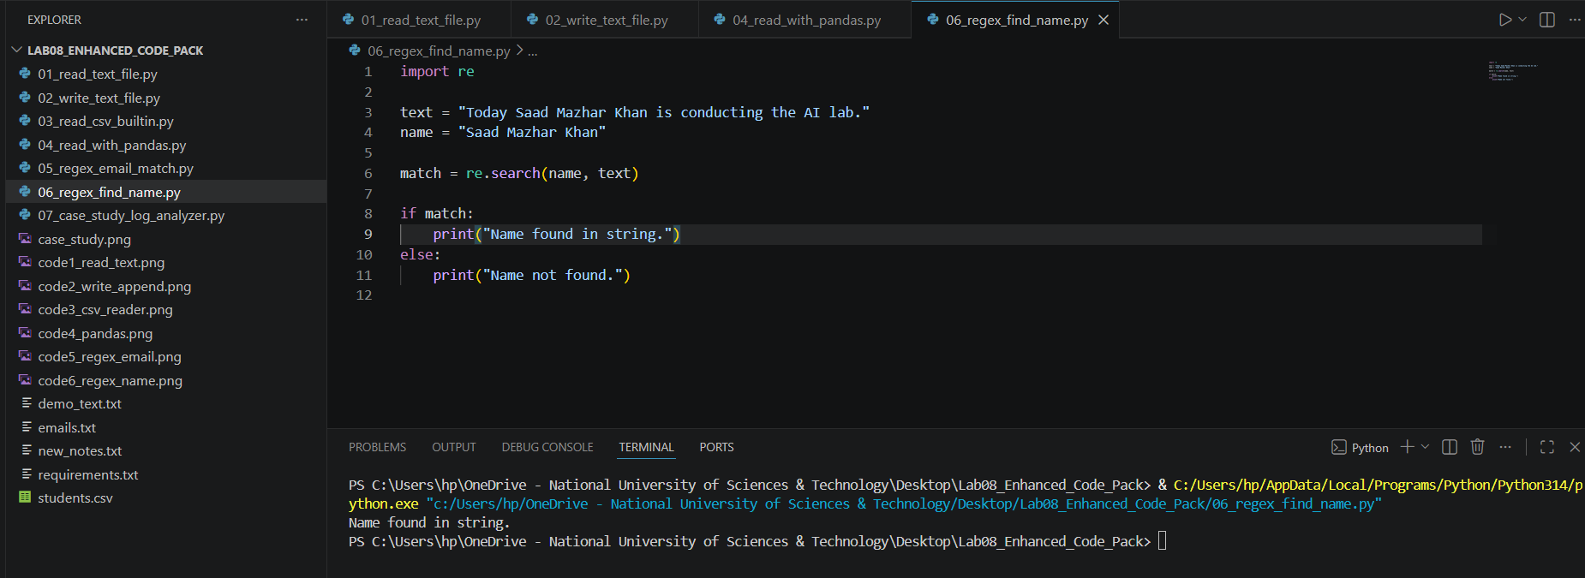

Example 7: Real-time mini case study
File name: 07_case_study_log_analyzer.py
This program reads student records from a CSV file, identifies underperforming students, checks email validity, and writes a report file.
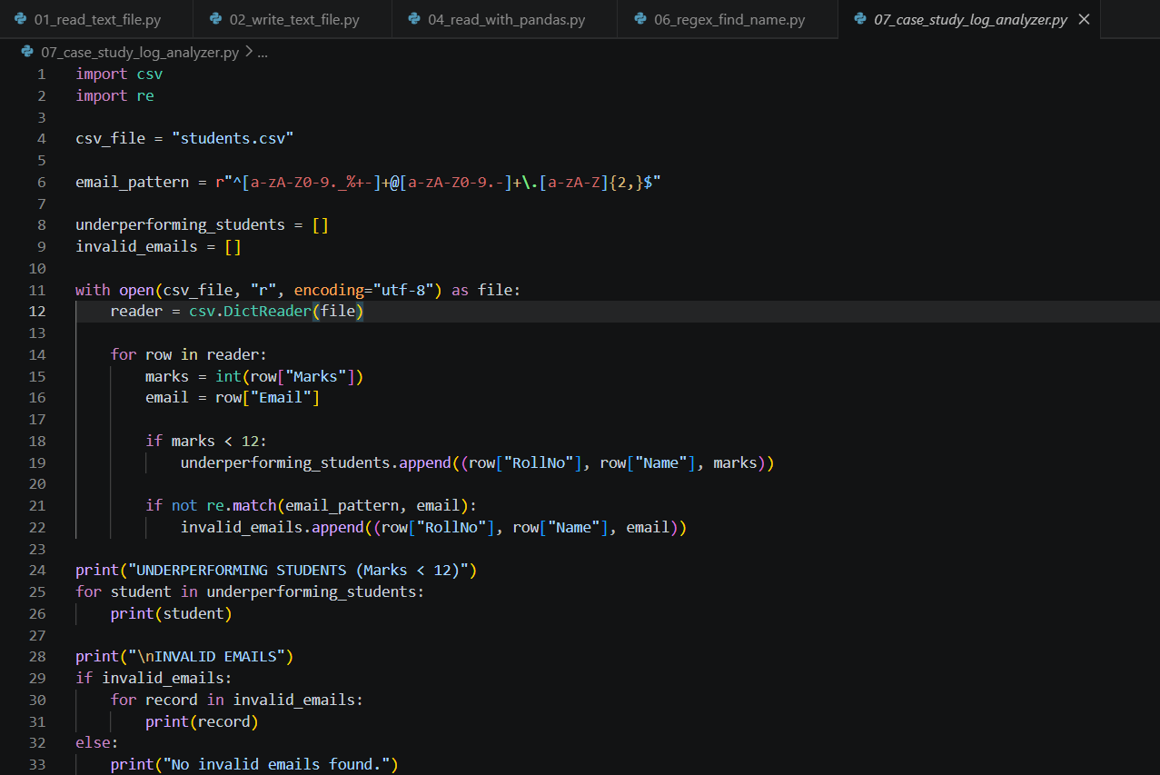
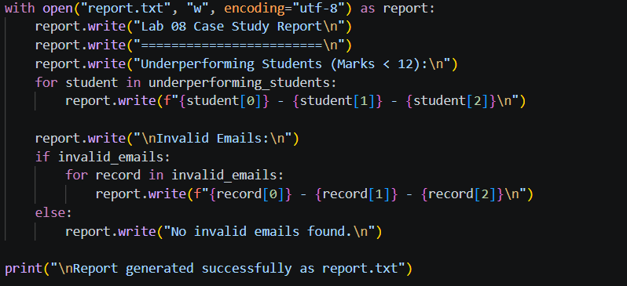

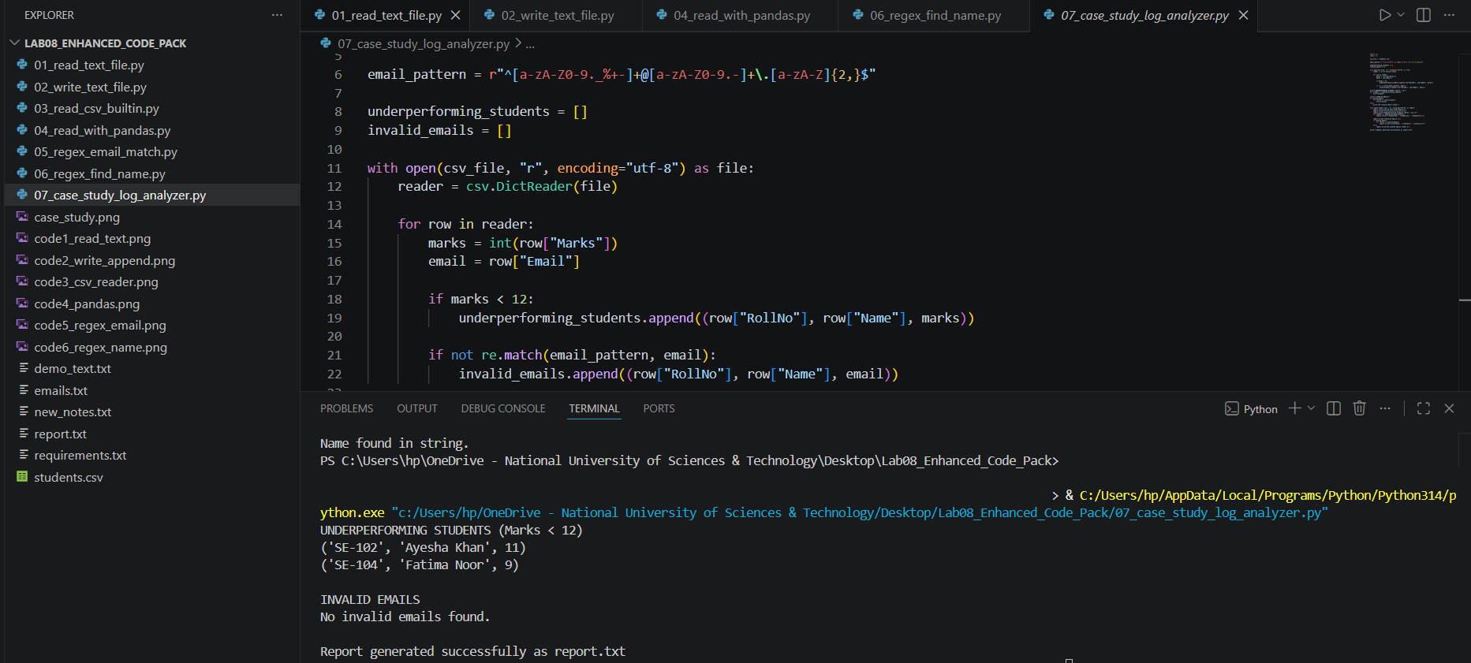

Exercise:
Case Study: You are working as a junior software engineer in a university student support office. You receive a CSV file containing student names, marks, and email addresses. Your task is to automate basic checking.
Problem | Student Task
Some students scored poorly | Identify students having marks less than 12
Email data may be wrong | Use regex to validate the email format
A report is needed | Generate a report.txt file with results
Manager wants proof | Show output in terminal and include screenshots in the manual

Expected deliveries from students:
- Python file containing the final solution
- Terminal screenshot of program output
- Generated report.txt file
- Short explanation of logic used

